High Level Design – Training Management System

**Team: Euphoria**

**Version:** 1.0

**Date:** April 20, 2022

Table of Contents

**1. System Architecture** **iii**

**2. Interactions** **iii**

**3. Non-Functional Requirements** **iii**

**4. Data Model** **v**

**5. Database Diagram** **v**

**6. Services and Dependencies** **v**

**1.System Architecture:**

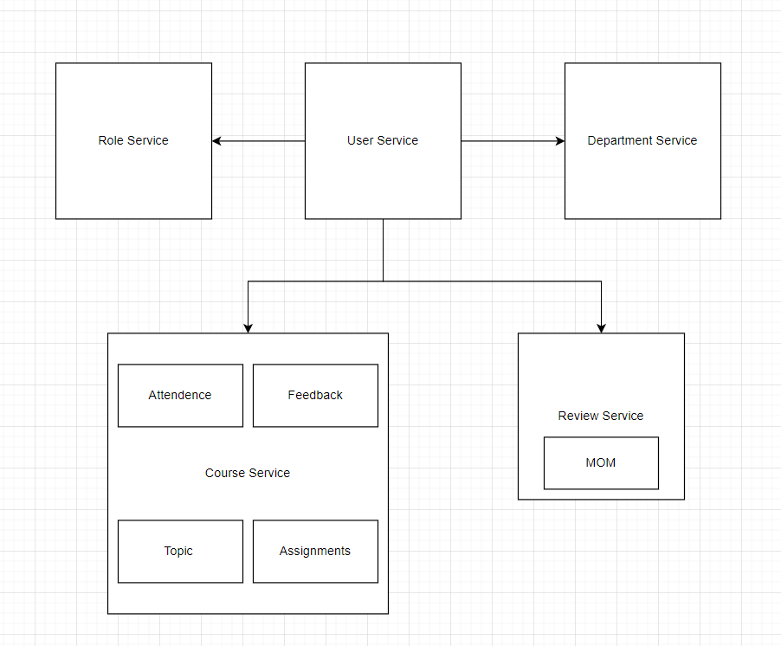

**2.Interactions:**

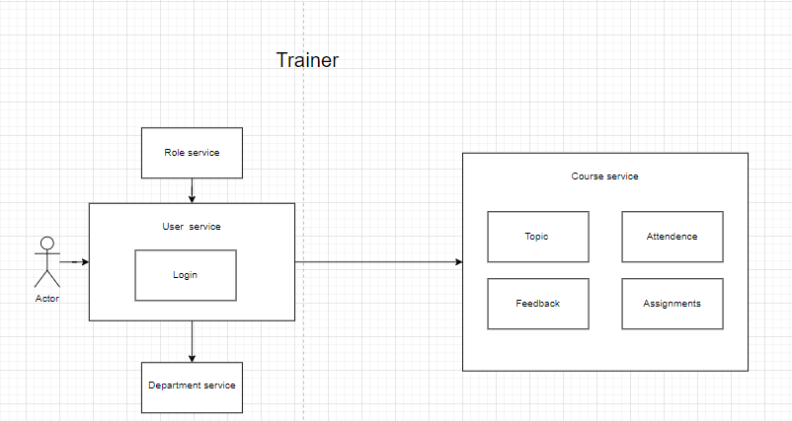

Trainer will use the above services, based on the role and user service trainer can login to the system. Trainer must be allocated to the department using department service. The trainer can access topic, attendance, feedback and assignments which is dependent on the course service.

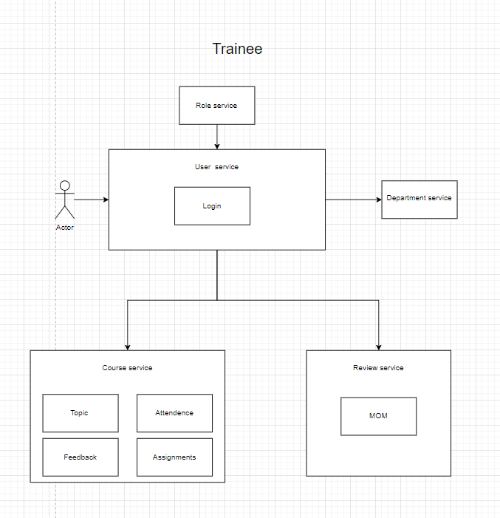

Trainee will use the above services, based on the role and user service trainee can login to the system. Trainee must be allocated to the department using department service. The trainee can view topic, assignments, and mark attendance, give feedback which is dependent on the course service. And using the review service trainee can attend review and submit MOM.

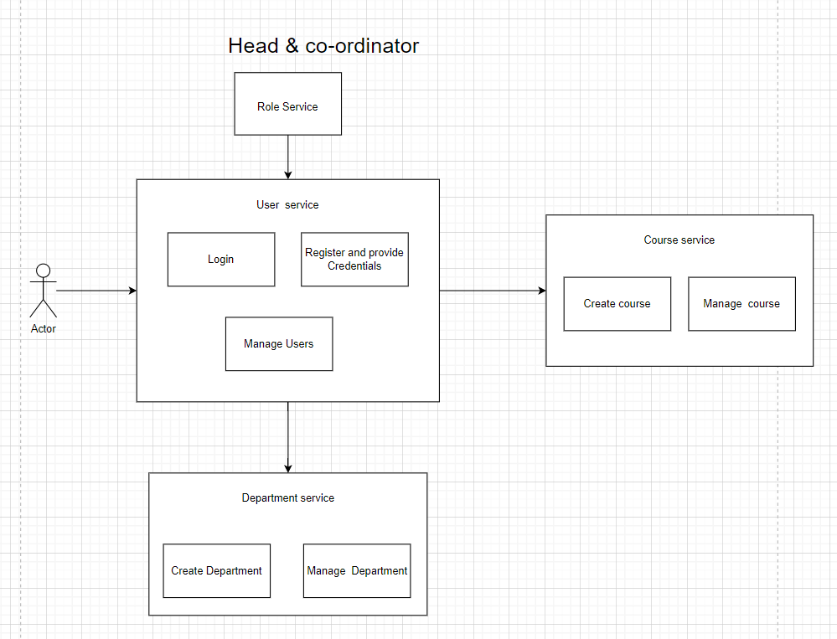

Head and Coordinator will use the above services, based on the role and user service they can login to the system and can provide credentials to others. Coordinator can create and manage the course using course service, and create department using department service and head will manage coordinator and view all the actions done by the coordinator, trainee and trainer.

**3.Non-Functional Requirements:**

**Responsiveness:**

Responsiveness means the ability of a software system to work in a different environment if the underlying dependent framework stays the same.

**Usability:**

Usability requirement specifies how easy the TMS must be to use. It measures the usability of the system being developed. It should be convenient to use and user-friendly.

**Maintainability:**

Maintainability of a software system is the ease with which the system can be maintained. In addition to a variety of technical approaches to ensuring maintainability, such as high cohesion / loose coupling, SOLID principles, using standard API formats and clear document interfaces, it’s important to track code, exception and architecture metrics so that you can see where issues may be occurring and improvements needed

**Scalability:**

TMS has ability to appropriately handle increasing (and decreasing) workloads. It means that the system must be able to accommodate larger volumes of data over time, and also includes the elasticity, which is the ability to scale up and down quickly, as needed.

## **Security:**

In our TMS we built a data security system, where only the user who has the valid login credential can login and access the relevant data to him and not others data.security includes confidentiality and authentication to ensure this information is protected by default.

## **Feedback Requirements:**

In our TMS, we collect feedback from the trainer as well as trainee. This will be used to enhance the further performance.

**4.Data Model:**

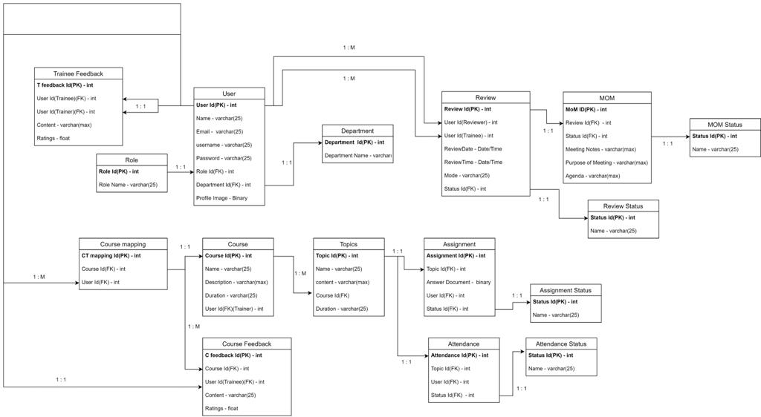

**5.Database Diagram:**

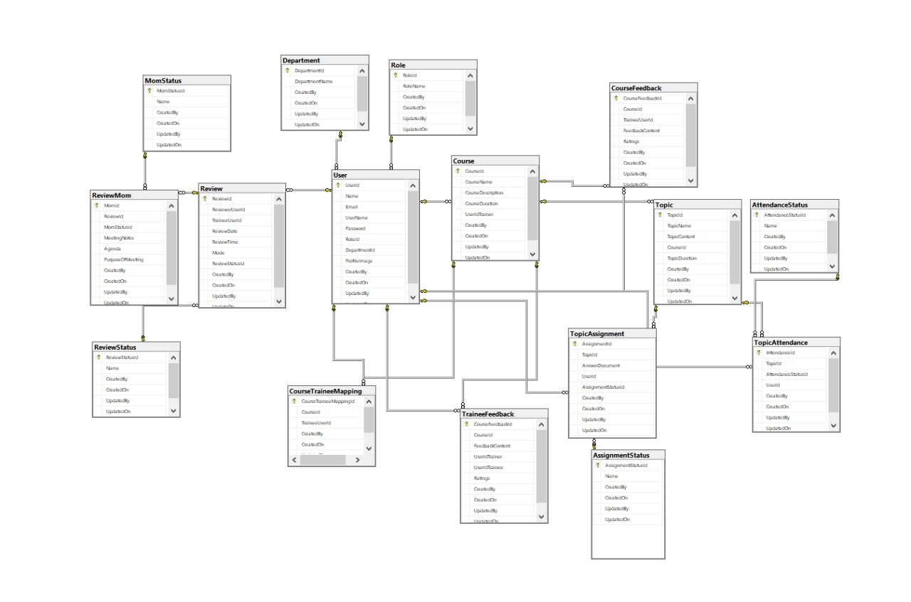

**6.Services and Dependencies:**